Group Members:

**Ibrar Babar (19p-0104)**

**Asjid Tahir (19p-0085)**

Subject: Communication and presentation skill

BS(CS): SECTION (B)

ASSIGNMENT: [Cultural Differences]

**{Mam Maryam}**

**Question :**

 Compare and contrast any two cultures and highlight how cultural differences can become a hurdle in communication. (Discuss verbal and non verbal both).

**Answer:**

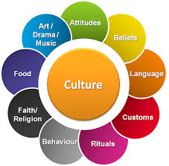 **Culture:  
 Culture** is the total way of life of particular groups of people. It includes

everything that a group of

people thinks, says, does

and makes — its systems,

attitudes and feelings.

**CULTURE DIFFERENCE BETWEEN PAKISTAN AND INDIA**

**CULTURE OF Pakistan:**

The society of Pakistan has many different cultures. The east of country is mainly **Punjabi**,

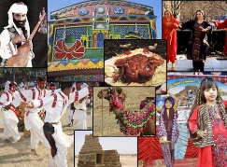 the south is mainly

**Sindhi** in the east

are the tribal

countries. In many

**areas** the tribes and

cultures are mixed, most Pakistanis are Punjabi.

If there is a country whose culture is starkly contrasted by its international image, it has to be **Pakistan.**

**Pakistanis** all over the world often face the **dilemma** of explaining what their culture really entails, thanks to years of news-media exaggeration and agenda setting.

**Indian Culture:**

India is a very diverse country, and different religious have their own district cultures. Language, religion, food and the arts are just some of the various aspects of Indian **culture.**

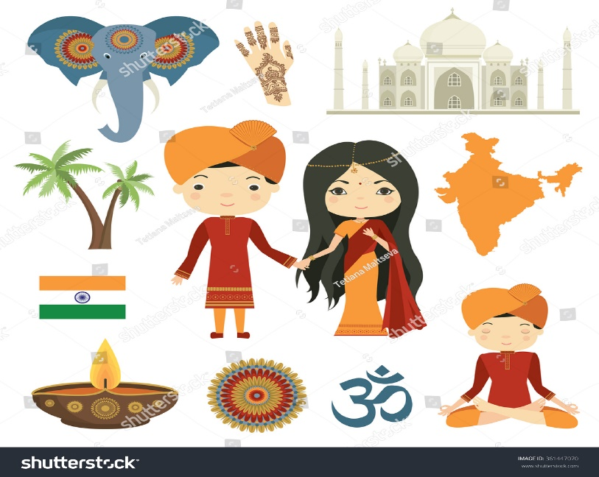The Indian culture, often labeled as an **amalgamation** of several various

**cultures,** spans

across the Indian

**subcontinent** and

has been

influenced and

shaped by a history

that is several

thousand years old.

**India** is one of the most religiously and ethnically diverse nations in the world, with some of the most deeply **religious** societies and **cultures.**

**Religion** plays a central and definitive role in the life of many of its people. Although India is a secular Hindu-majority country, it has a large **Muslim population**.

**DIFFERENCE BETWEEN PAKISTAN AND INDIA culture**

A difference came between these two cultures through the following points.

* Religion
* 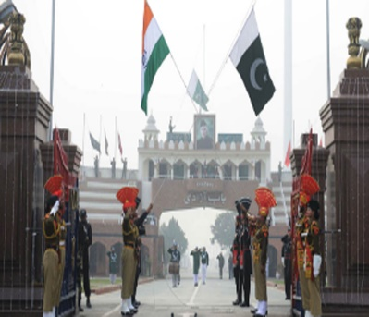Language
* National symbol
* Dress
* Sports
* Festivals
* Greetings
* Custom & Traditions
* Marriage
* Death Ceremonies

These are the **points** which are can come in **between** these two cultures, and through these points we can **differ** these two **cultures.**

Let’s Discuss the following Points one by one that come in the culture differences of **Pakistan** & **India**.

**Religion**

**Pakistan India**

Pakistan is an ideological The major religion of India

Islamic state. Its existence is are Hinduism (Majority

Due to **Islam**. So Pakistani religion), Islam, Sikhism

Culture is primary based Christian, Buddhism, and

on Islamic way of life. Jainism.

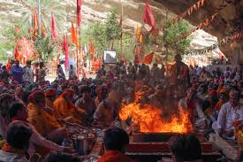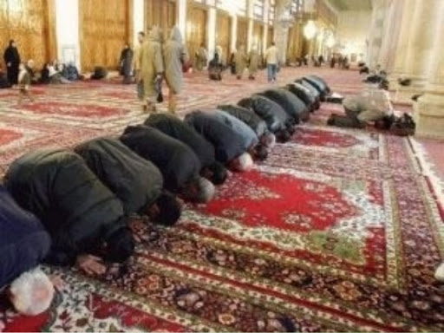

That is the basic first culture difference between

Pakistan and India.

**Language**

**Pakistan India**

Two official languages Two official languages

Of communication of communication is

Is Urdu and English. Hindi and English.

The regional language The regional languages

Of Pakistan are Punjabi, of India are Gujarati,

Balochi, Pushto, Saraiki. Marathi, Tamil, Urdu,

Urdu is the National Teglu, Punjabi and

Language of Pakistan Many more.

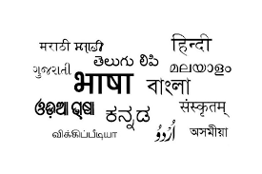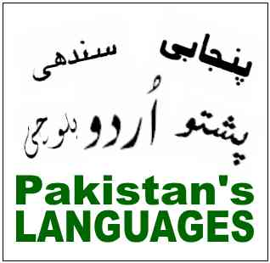

**NATIONAL SYMBOLS**

**Pakistan India**

Animal: Markhor Animal: Tiger

Bird: Chukar Bird: Peacock

Flower: Jesmine Flower: Lotus

Fruit: Mango Fruit: Mango

Game: Hockey Game: Hockey

Tree: Deodar Tree: Indian fig tree

River: Indus River: Ganga

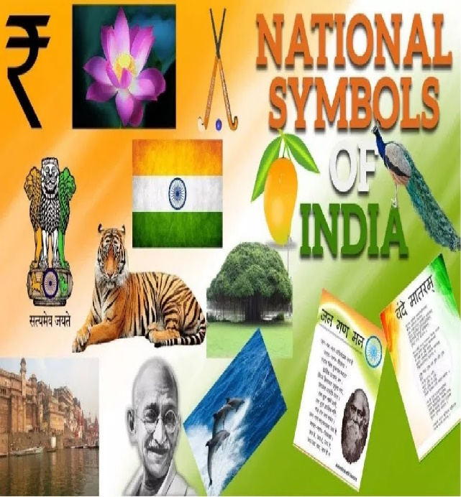 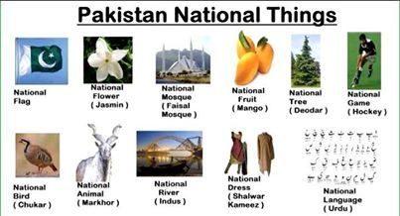

**dress**

**Pakistan India**

Each province has its Different part of the

own style of wearing. Country have

Such as man wear different styles of

shalwar kameez, Kurta dressing.

shalwar, and dhuti kurta. Such as Sari and

Women wears shalwaar Churiddar for Women.

kameez, churiddar with Men wear Dhoti Kurta

kurta or frok. and Pent shirt.

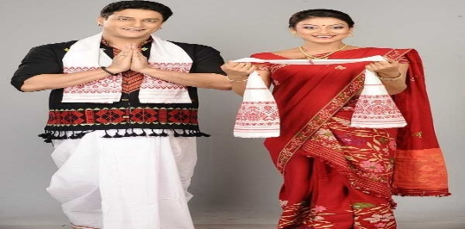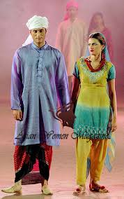

**Sports**

**Pakistan India**

Many games played in Many games played in

Pakistan which reflects India which reflects

cultural identity. cultural identity.

Hockey, cricket, football, Cricket and Hockey are

Badminton, basketball, most popular games.

and squash are the most Netball is most important

popular in Pakistan. Game in India.

Different shoes are Kabaddi is most

arranged in rural areas popular game in

like puppet show. India.

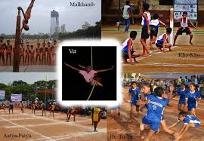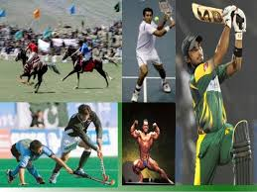

**Festival**

**Pakistan India**

The customs of Muslims India is the multi-cultural

of the **Pakistan** are the and multi religious,

same everywhere. Celebrate festivals of

**Eid-ul-Fitr**, **Eid-ul-azha**, various religions.

**Eid Milad-un-nabi**, and Dewali, Holi, Guru purnima

the **Urs** at the shrines Ram Navami, Raksha

of the saints are held bandhan are some of the

every year. Festivals of India.

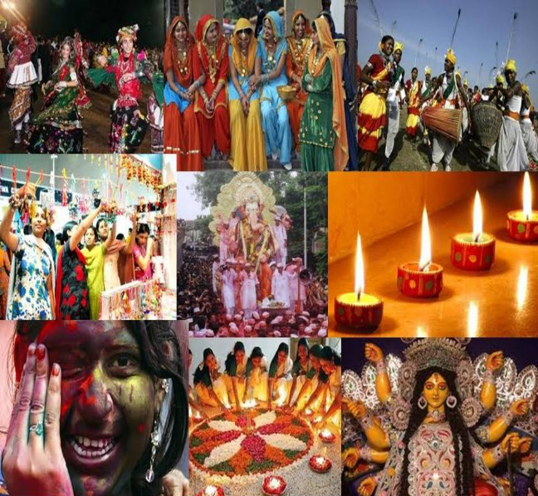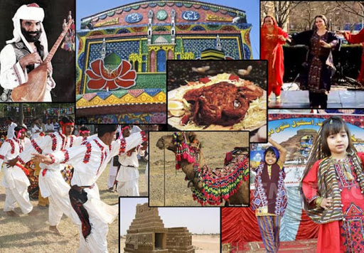

**Greeting**

**Pakistan India**

The only way of Common greeting

greeting in Pakistan in India are:

is: “**Namaste”**

**“Assalam o alaikum” “Ram Ram”**

“**Sat sahri akal”**

“**Jai sari ram”**

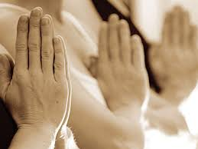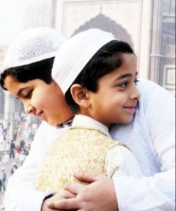

**Custom and traditions**

**Marriage**

**Pakistan India**

In **Pakistan**i the culture Weddings are festive

Muslims celebrate a accasions in India that

traditional Islamic wedding. Depend on religion.

The rituals include **Nikah**, In hindu wedding

payment of financial **Kanyadaan,** and

dower called **Mahr** by **saptapadi.**

the groom to the bride, Gifting away of daughter by

signing of marriage contact, the father.

and the reception.

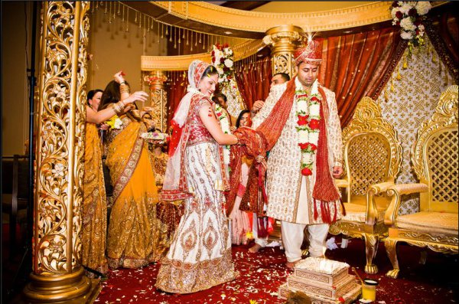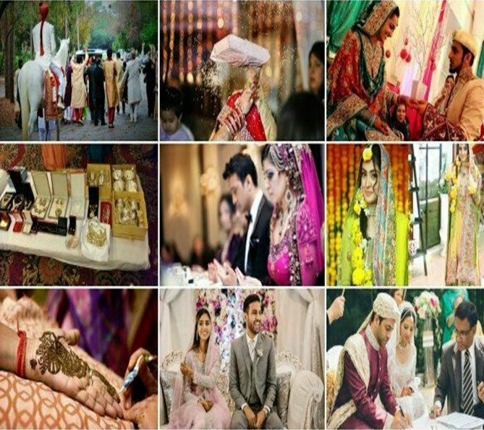

**Custom and traditions**

**death**

**Pakistan India**

In Pakistan after the In India Hindus do not

death of any Muslim buried their bodies

the body should be they burn their bodies

buried as soon as and after burning their

possible from the time bodies they put them

of the death according in Ganga river.

to Islamic law.

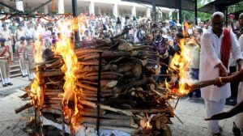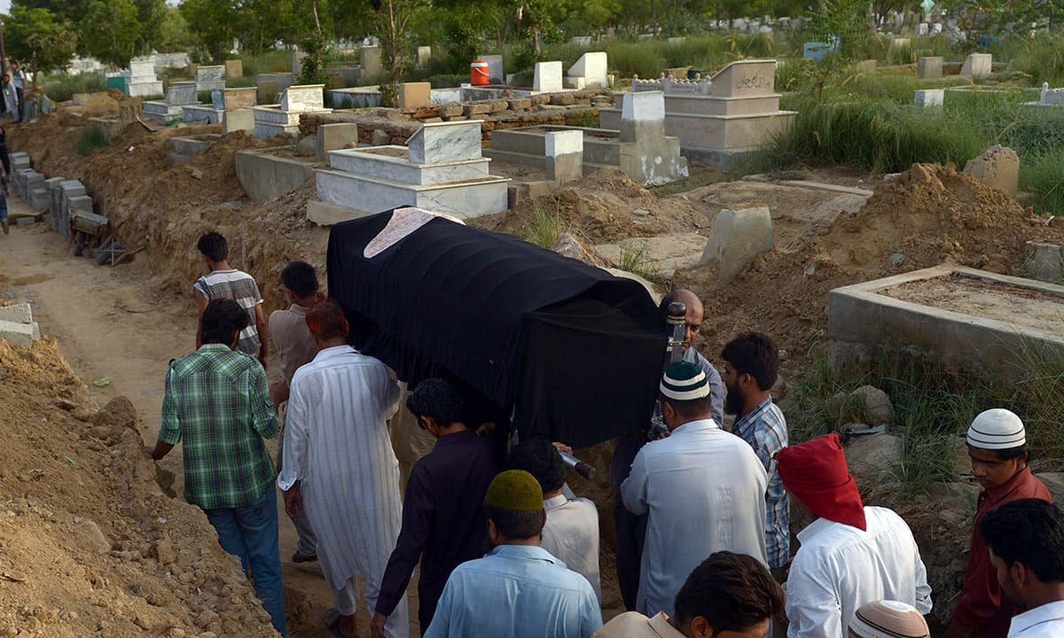

**Conclusion:**

There are a lot of differences between cultures of **Pakistan and India**. In spite of all these difference, there are some common **custom** also. The main difference are **religion beliefs** which differentiate the way of the life of both nations.

Through that differences between these two cultures.

There are many points come across through which both (verbal **&** non-verbal **communication**) become **barrier / hurdle** between these **two** cultures.

So that we can say that due to a lot of differences between these two cultures, there relation should **not good** from start.

From these points it is clear that these two **cultures** are almost totally different form each other.